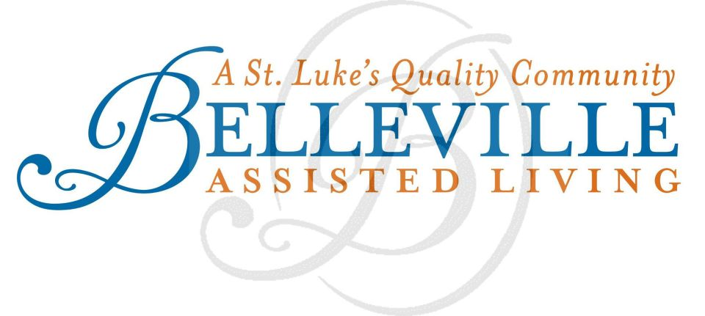
Media Contact:
Sarah Chambless
Gambel Communications
(o) 504-324-4242
(c) 985-373-5271
sarahc@gambelpr.com
FOR IMMEDIATE RELEASE
***MEDIA ALERT***
Belleville Assisted Living Proudly Sponsors Treasures from the Point
Center to host open house, bake sale and live music during Algiers Point’s community-wide porch sale
WHO: Belleville Assisted Living Center

WHAT: Belleville Assisted Living is proud to sponsor the 10th Annual Treasures from the Point event, Algiers Point’s “Porch Sale of the Century.” At this event, more than 90 homes and businesses in historic Algiers Point host individual porch sales that include a variety of items, from antiques and furniture to electronics and appliances.
Belleville residents, in partnership with Jefferson Chamber Foundation Academy (JCFA), will sell freshly baked treats and coffee during the community-wide event. Belleville will donate all proceeds from the bake sale to JCFA.
Attendees are also invited to enjoy live music by Hazel and the Delta Ramblers and to take a free guided tour of the historic Belleville property during the event. Belleville’s restrooms will be open to the public during the event, and event maps will be available for pickup on site.
WHEN: Saturday, April 5, 2014
Bake Sale and Coffee to benefit JCFA
8 AM – 3 PM
Free Guided Tours of Belleville
9 AM – 3 PM
Live Music by Hazel and the Delta Ramblers
10 AM – 12 PM
WHERE: Belleville Assisted Living
813 Pelican Avenue
New Orleans, LA 70114 (in Algiers Point)
WHY: Belleville Assisted Living residents are proud to give back to local youth by hosting a bake sale to benefit Jefferson Chamber Foundation Academy (JCFA), the country’s first charter school to come out of the Chamber of Commerce and the second charter school in Jefferson Parish. JCFA aims to lower dropout rates by offering a non-traditional path to a high school diploma for at-risk students. Since 2010, JCFA has focused on providing youth in Jefferson Parish with an innovative way to earn a high school diploma.
Belleville Assisted Living will give attendees the chance to enjoy live music on the lawn and tour its historic, beautifully-preserved campus during Treasures from the Point. Belleville, which was formerly the site of Belleville Elementary School, was recently granted an Award for Excellence in Historic Preservation by the Louisiana Landmarks Society. This award honors projects completed in Orleans Parish in 2012 or 2013 that represent outstanding examples of restoration or rehabilitation of historic buildings, as well as new construction in a historic district. Belleville is one of 15 projects that the Louisiana Landmarks Society honored with this distinction.

HOW: This event is free and open to the public. For more information about Treasures from the Point, visit www.TreasuresFromThePoint.org.
About Belleville Assisted Living:
The mission of Belleville Assisted Living, the newest member of the St. Margaret’s family of healthcare providers, is to serve the New Orleans community by providing the highest quality of service and care possible. Belleville continues the legacy of compassionate care that began with the founding of the original St. Margaret’s healthcare facility in 1931. Over eight decades later, we have not wavered in our resolve to create a home for our residents and provide New Orleans Assisted Living Services that make the lives of our elderly easier and more enjoyable. For more information about Belleville Assisted Living, visit www.bellevilleno.org.
###

